Team Bee Communication

# Communication Methods:

Due to the Hawkes Bay cyclone in February of 2023, we were unable to work on this project face-to-face on campus. Because of this, we used three main methods of online communication, each one achieving a different purpose.

**Trello:**

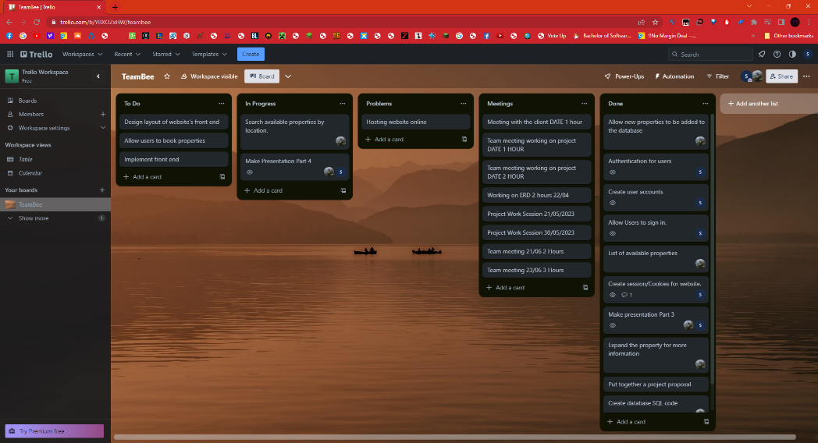

Trello allowed us to create and allocate the most important tasks of our project. We had multiple sections such as to do, in progress, problems, meetings and done. Our tasks were assigned to each of these categories depending on where we were in the project, which allowed us to keep track of what we were doing and what was yet to come. We allocated the different tasks between ourselves, some individual, some collaborative. We also dedicated a category to team meetings, where the duration and dates were recorded as evidence.

**GitHub:**

GitHub was likely the most important tool used in the development process, as it not only allowed us to manage the project’s source code, but also provided an issues tab where we could give progress updates for our various tasks to be documented. Our project was stored both as a “wpress” file, containing both the WordPress file and the plugins we had added to it, as well as the individual plugin files so that we could make small updates to our work without needing to reinstall the entire project. As for the GitHub issues page, it worked very similarly to Trello in that we could create tasks and assign them to people. Trello was still better for progress tracking, but this was a good place for updates through text and images. 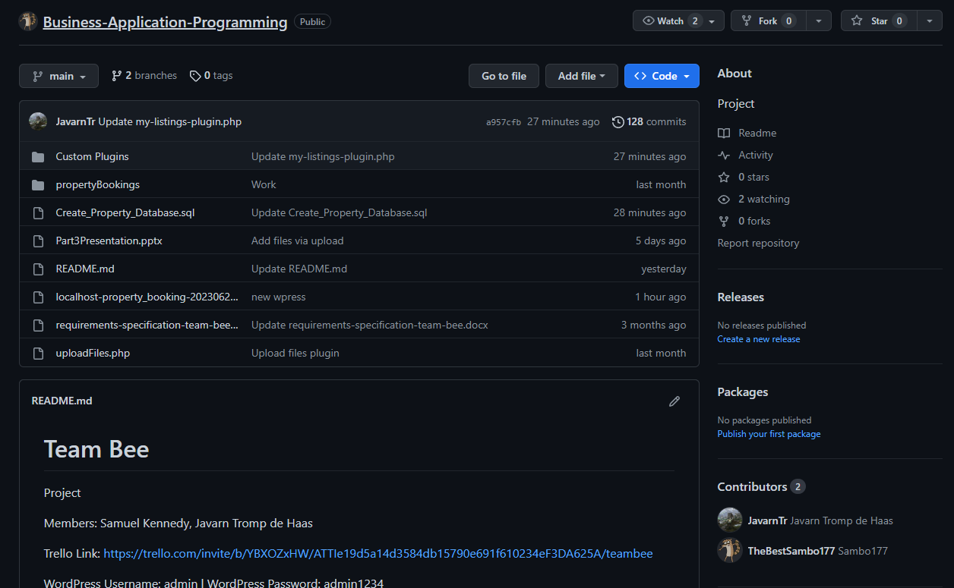

**Discord:**

This is where we regularly talked about our tasks and how we were doing with them. During our team meetings we would heavily discuss any issues we would have and try to work on the problems together. These meetings were highly conducive blocks of work that heavily aided our completion of the project.

Below is a list of team meetings as screenshots:

